# Study of Roles

**Characteristics and activities of the roles**

**Project manager**

The project manager controls and manages the project resources in order to fulfill the defined plan and objective.

The administrator does not own anything; he is only a temporary administrator of the resources. Since you do not own anything, you must leave them in the same or better condition as you received them. Therefore, the focus of good administration must be on the control and coordination of the different events and activities of a project.

Some of the activities that they carry out are:

Make the Gantt diagrams and flow of activities, develop a work plan, contract with the client and activities of organization, direction and control.

**Analyst**

Analysts must identify the client's needs, through meetings with the client or their representative. These needs must go from a language that dominates the client to a language that dominates the team.

Bring the team the necessary knowledge to understand and execute the software.

Some of the activities that they carry out are:

Interview the client, helping him identify his needs, verify if the specified requirements are correct, define a basic structure of the system that includes information sources, information processing modules, and expected results, perform the analysis of the requirements, analyze the basic structure of the system, generate the diagrams of the architecture.

**Designer**

Generate the architectural design and detailed design of the system, based on the requirements, generates rapid system prototypes (with analysts and programmers) to check the requirements, generate the software architectural design document (DDA), and keep it updated during the project, ensure that the final product fits the design made (tester functions).

Some of the activities carried out are:

Define the management of access to global resources, select a data storage management technique, interact with programmers, assign subsystems to processors, manage concurrency, select control strategies.

**Programmer**

It is responsible for translating the system specification into code.

Learn on your own new technical and non-technical skills, be pragmatic, not dogmatic, know how to look for solutions to problems, have passion for your work, leave your ego at the door, have an entrepreneurial spirit, think before you act, but do not fall into the envelope design (personal translation of "Measure twice, cut one, but do not measure more than three times").

Some of the activities carried out are:

Explore the different environments in which the system can be developed, interact with analysts and designers, explore the different languages available for the selected environment, interact with the designers, explore different development tools (compilers, debuggers, etc.) available for the selected language, explore the different coding styles that can be used in the selected language, perform the coding of the system, interact with the testing engineers and support them.

**Tester**

They are in charge of the generations of test plans, of finding errors in the application and of documenting the findings, planning and executing test cycles.

Some of the activities that they carry out are:

Participation in the process of specifying the system, interaction with the designer, carrying out the tests, supported by the programmers and reporting on the results obtained.

**Documenter**

During the software development process, a large amount of documentation is generated. Said documentation must be stored in the project repository. The documentation serves, among other things, to know the history of the project. It should be noted that the documents are not written at the end of the project, but are generated together with the different phases of the project.

Some of the activities that they carry out:

Design and build a repository of shared information, where the documentation will be stored, keep the information repository updated, specify the format that will be used to prepare the documentation, ensure that the documents maintain the documentation standard defined for the project before including them in the repository, during the review meetings, the documenter will prepare the minutes of the meeting.

These documents will then be used by the validation and verification engineer, to elaborate the system's user manual, MUS.

**Assignment of the mentioned roles**

**Joanna Elizabeth Campos:** Designer, analyst.

**José Luis Corona:** Programmer, Tester.

**Rogelio Almanza:** Project manager, programmer.

**Juan Manuel Conejo:** Programmer, Documenter.

**Justification**

Joanna Elizabeth is in charge of designer and analyst due to her experience in making multimedia guides, websites using WordPress, which are jobs that need an attractive and efficient design.

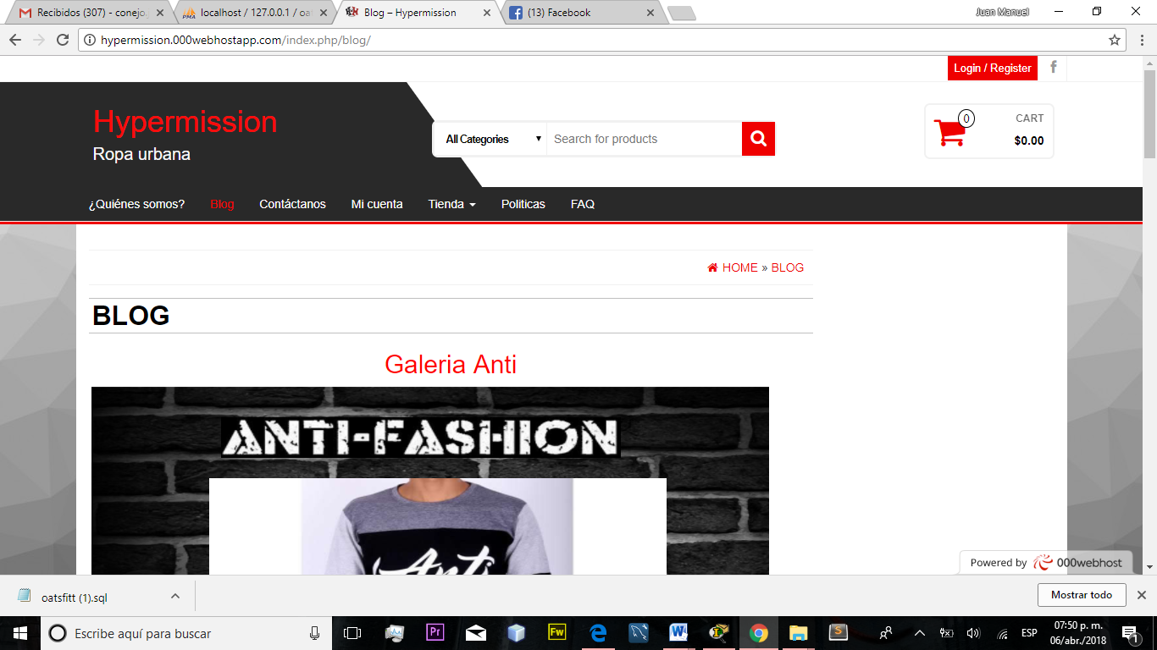

José Luis Corona is in charge of programmer and tester for having developed a website for Jumapaa and experience programming with Java, PHP and framewoks.

Juan Manuel Conejo is in the position of programmer and documenter for his experience in developing websites, and his work in IEEG as a data capturer.

Rogelio Almanza is in charge of project manager and programmer due to his previous work as a leader and administrator of application development projects and websites.